SPINACH


C Level Specification
for
Interpreter Front End

Version 1.0
9th November, 2009

CSE 784 – Software Studio

Kuldeep Gandhi
Deepak Goyal
Srinivasan Sundararajan
Vinit Mehta

Srinivasan:
- if statements (f)
- for loops (h)
- parallel for loops (i)
- parallel for synchronization statements (j)

Vinit:
- BODMAS
- Function definition
- Function call
- Equality and non equality operations.

Kuldeep:

- Class Element:

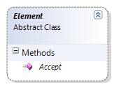

- Class Return Element:

Syntax: return a;
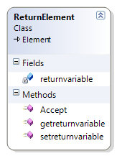

Return element would just set the return variable. It can be included in any loops or any function definition.

- Class MatrixTranspose

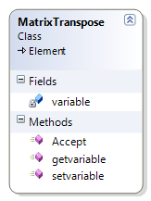

Syntax: Ta where is a is a matrix element.

- Class AdditiveElement

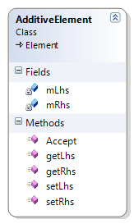
CLASS NAME – AdditiveElement
This class supports addition operation statements. It inherits from the Element class and would support a statement of the following type.

Example: A + b*(a-c)

So, additiveElement would have :
Lhs = A;
Rhs = b*(a-c);

The additive operations can only have multiplication , bracket or any other addition element on its lhs or rhs.

.

- Class MatrixReference:

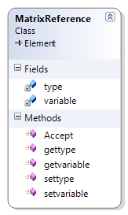

CLASS NAME – Matrixreference Element
This class supports passing matrix elements as function arguments in function statements. It inherits from the Element class and would support a statement of the following type.

Example: Matrix<int> a;

So, Matrix reference Element would have :
Type: int;
Variable: a;

- SubtractionElement:

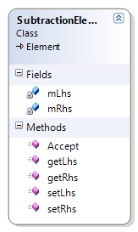

CLASS NAME – SubtractionElement
This class supports subtraction operation statements. It inherits from the Element class and would support a statement of the following type.

Example: A - b*(a+c)

So, subtraction Element would have :
Lhs = A;
Rhs = b*(a+c);

The subtraction operations can have all other BODMAS operations element on its lhs or rhs.

- BracketElement:

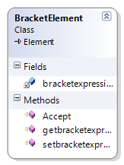

CLASS NAME –Bracket Element
This class supports Bodmas Bracket statements. It inherits from the Element class and would support a statement of the following type.

Example: (A+B-C*D)

So, Bracket Element would have:
It would the entire bracket expression as (A+B-C*D)

The , Bracket Element operations can have only all operations element in the expression.

- Class MultiplicationElement:

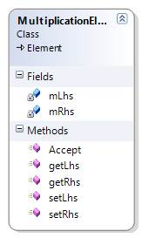

CLASS NAME – MultiplicationElement
This class supports multiplication operation statements. It inherits from the Element class and would support a statement of the following type.

Example: (a+b-c) *d

So, subtraction Element would have :
Lhs = (a+b-c);
Rhs = d;

The multiplication operations can have only bracket element or other multiplication element operations element on its lhs or rhs.

- Class FunctionCallElement:

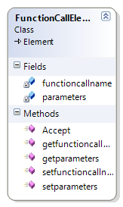
CLASS NAME – functioncallElement
This class supports function call statements. It inherits from the Element class and would support a statement of the following type.

Example: calculate(a, b);

So, function call Element would have :
Functioncallname : calculate;
List of Parameters: {a,b};

The function call can take in all types of arguments as matrix , vector , scalar variables and string.

- Class CommentElement:

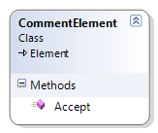

- Class FunctionElement:
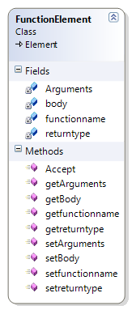

CLASS NAME – functioncallElement
This class supports function definition statements. It inherits from the Element class and would support a statement of the following type.

Example: int calculatesum (matrix<int> a , double b , vector<double> c)
{
//For statement;
//bodmas operations;
}

So, function definition Element would have :
Return type: int;
Functioncallname: calculatesum;
List of arguments: {matrix, scalar , vector};
List of Body:{for , bodmas};

The function call can take in all types of arguments as matrix , vector , scalar variables and string.
The function body can have an other spinach code other than another function definition element.

- Class VectorReference:

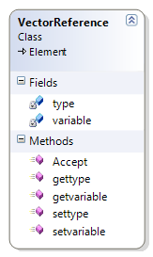
CLASS NAME – Vectorreference Element
This class supports passing vector elements as function arguments in function statements. It inherits from the Element class and would support a statement of the following type.

Example: Vector<int> a;

So, vector reference Element would have :
Type: int;
Variable: a;

- Class DotProductElement:

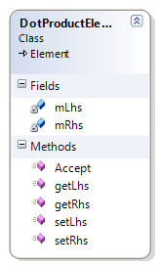

This class supports DotProduct operation statements. It inherits from the Element class and would support a statement of the following type.

Example: cDOTd

So, subtraction Element would have:
Lhs = c;
Rhs = d;

The dot product operations can have only vector element on its lhs or rhs.

- Class exec

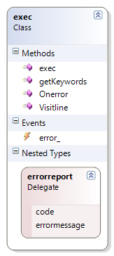

- Class Program:

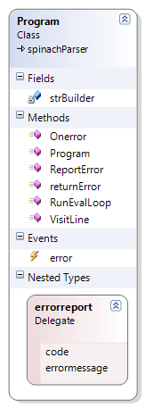

- Class Keywords:

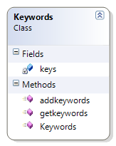

- Class IfStatementElement:

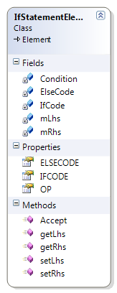
CLASS NAME – IfStatementElement
This class supports conditional if statements. It inherits from the Element class and would support a statement of the following type.

if(equality| nonequality | LessThan | LessThanEqualTo | GreaterThan | GreaterThanEqualTo )
{
//Valid Spinach Code
}
else
{
//Valid Spinach Code.
}

INTERFACES EXPOSED BY THIS CLASS:
IfStatementElement elem = new IfStatementElement();

- elem.OP This property returns the operation involved in the condition.
- elem.getLhs() This method returns the Lhs of the condition element.
- elem.getRhs() This method returns the Rhs of the condition element.
- elem.IFCODE;
This property returns a list of the valid Elements of the spinach code inside the if body.
- elem.ELSECODE;
This property returns a list of the valid Elements of the spinach code inside the else body.

- ForStatementElement:

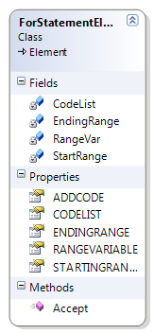
CLASS NAME – ForStatementElement
This class supports the for statements in the spinach code. This inherits from the Element class and would support for statements of the following type.

for(var->1to10)
{
//Valid Spinach Code.
}

INTERFACES EXPOSED BY THIS CLASS:
ForStatementElement elem = new ForStatementElement();

- elem.RANGEVAR;
This property returns the Range variable in the for loop.

- elem.STARTINGRANGE;
This property returns the starting range integer value in the loop.
- elem.ENDINGRANGE;
This property returns the ending range integer value in the loop.

- elem.CODELIST;
This property returns a list of elements that are present in the body of the for statement.

- Class ParallelForElement:

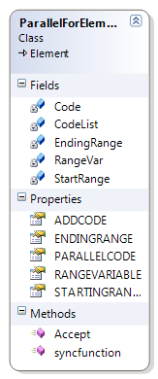
CLASS NAME – ParallelForElement
This class supports the parallelfor statements in the spinach code. This inherits from the Element class and would support parallelfor statements of the following type.

Parallelfor(var0to4)
{
//Valid Spinach Code.
SYNC;
//Valid Spinach Code.
}

INTERFACES EXPOSED BY THIS CLASS:
ParallelForElement elem = new ParallelForElement();

- elem.RANGEVAR;
This property returns the Range variable in the for loop.

- elem.STARTINGRANGE;
This property returns the starting range integer value in the loop.
- elem.ENDINGRANGE;
This property returns the ending range integer value in the loop.
- elem.PARALLELCODE;
This property returns a list of list of elements that are present in the body of the parallelfor statement. Code is made in to list of lists to separate the code that should be synchronized using SYNC statements.

///-- issues:

- string
- comment;

///-- completion table.

TEAM’s STATUS:

TASK | STATUS
Creation of variables | Completed
Creation of structure | Completed
Deletion of variables | Completed
Error to output | Completed
String Input | Completed with Issues
Non recursive functions | Completed
Matrix Operations | Completed with Issues
Comments | Completed with Issues
Testing Equality and Nonequality | Completed
If statements | Completed
For statements | Completed
Parallelfor Statements | Completed
Parallelfor synchronization | Completed
Plot functions | Completed

